Dimensions of my robotic Manipulator

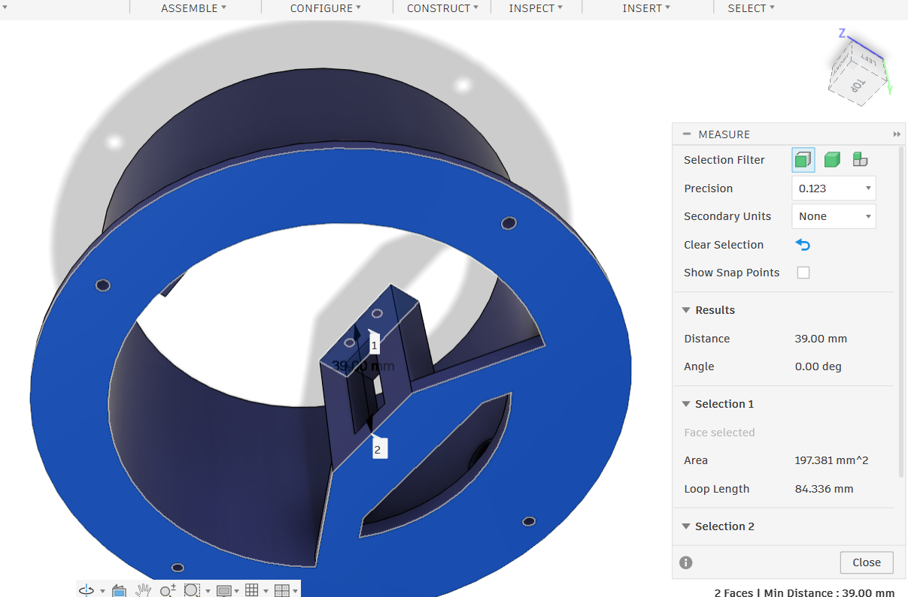

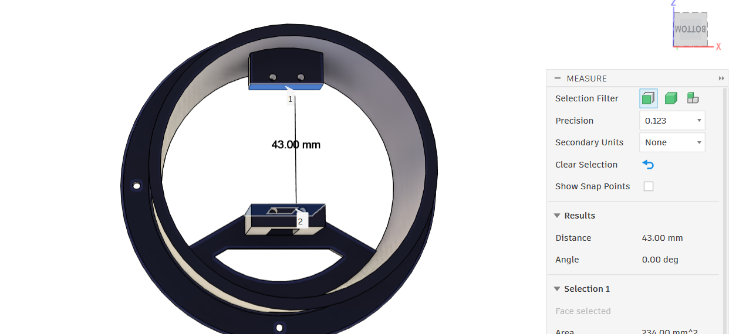

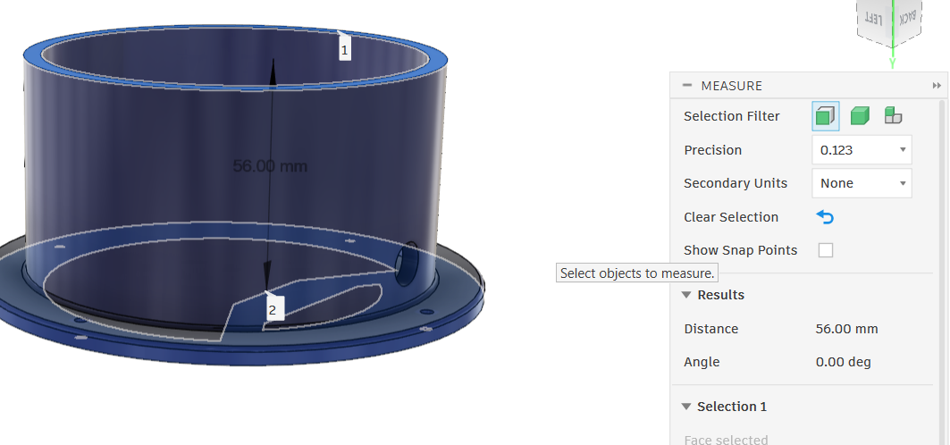

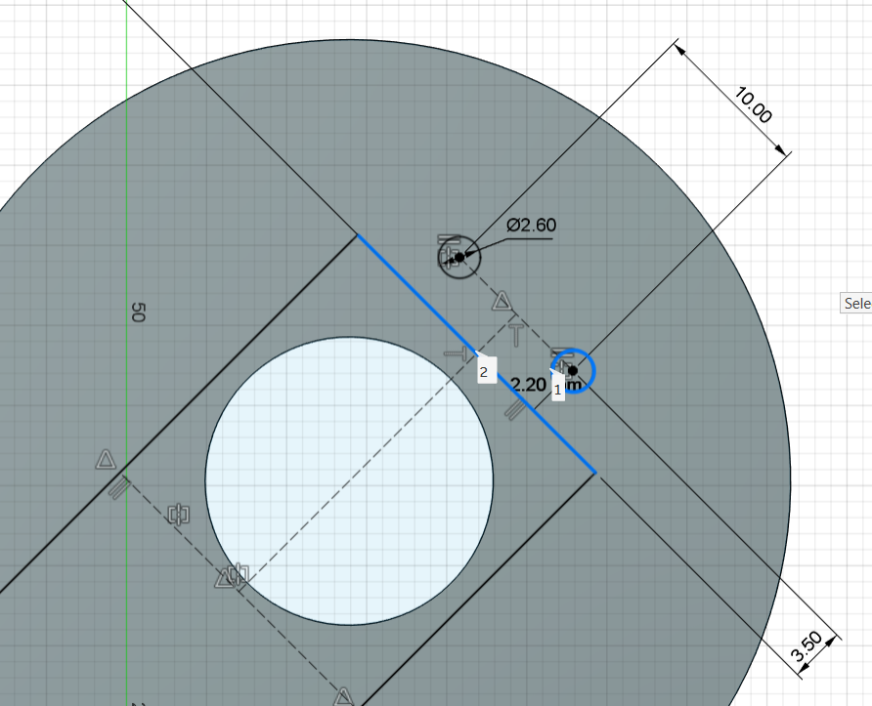

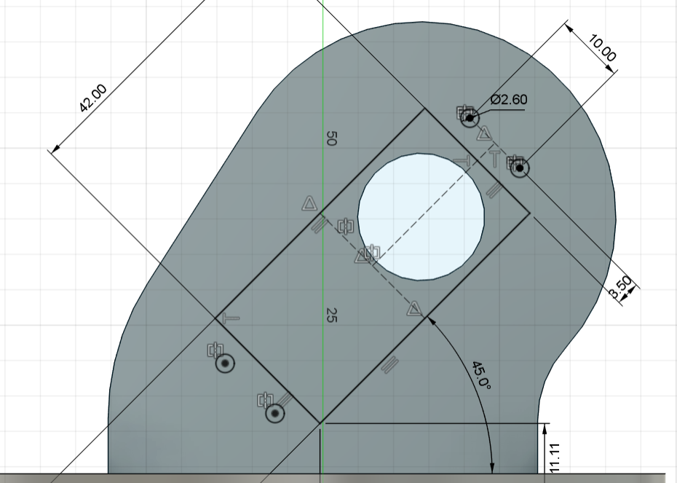

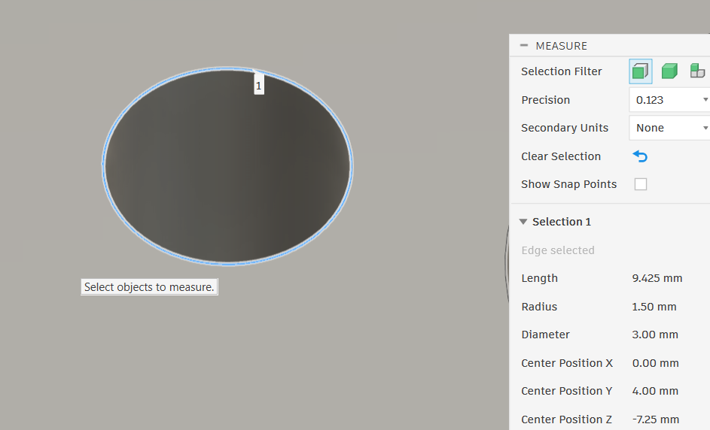
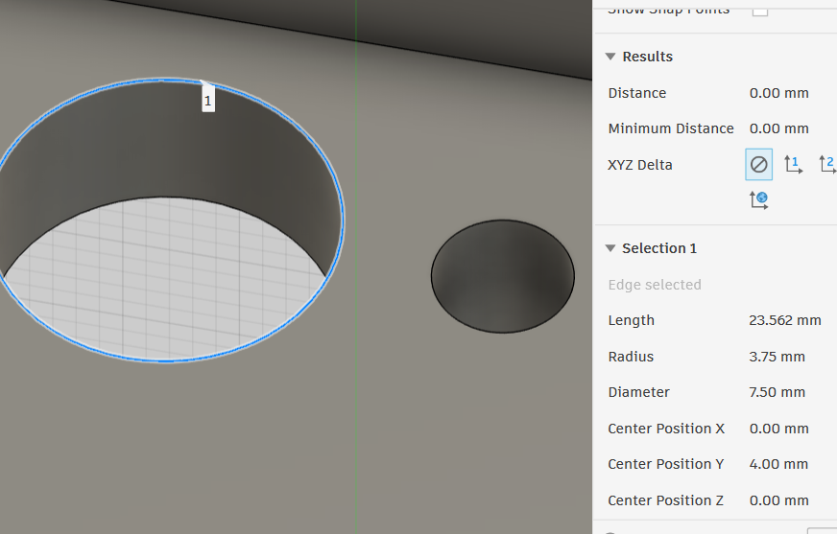
xs

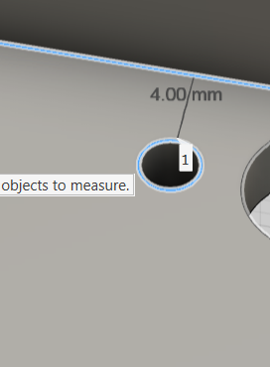

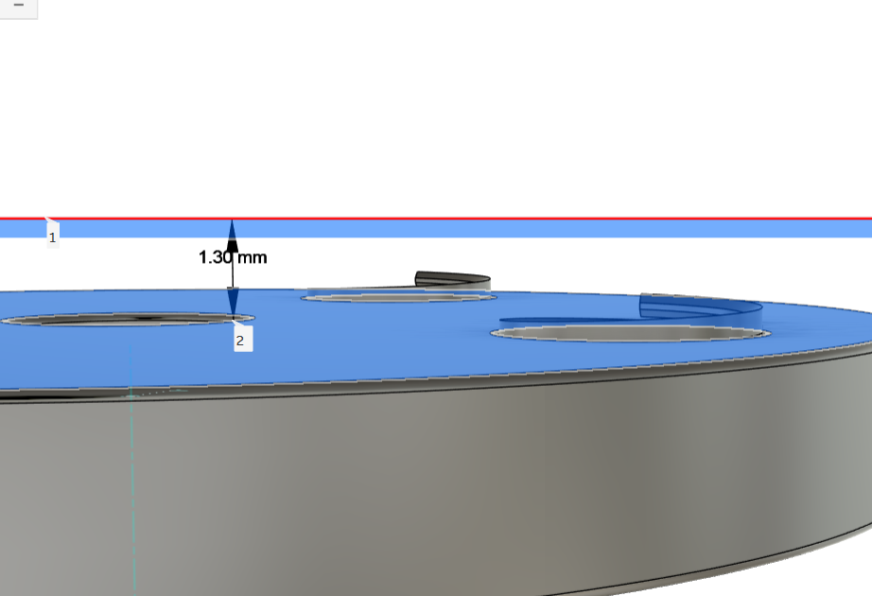

Minor error in between arm_base and servo round horn

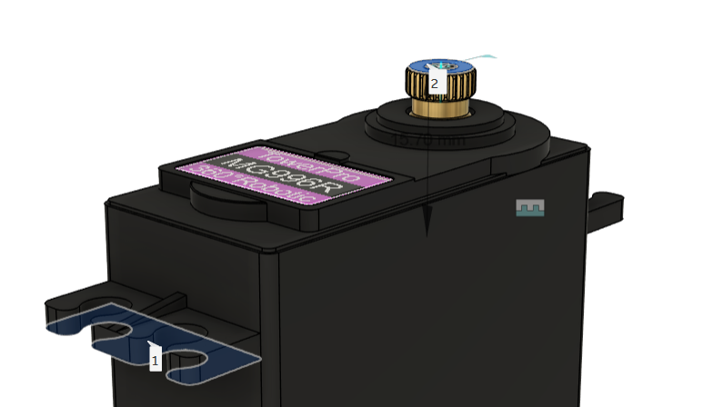

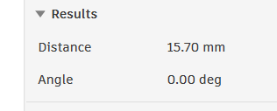

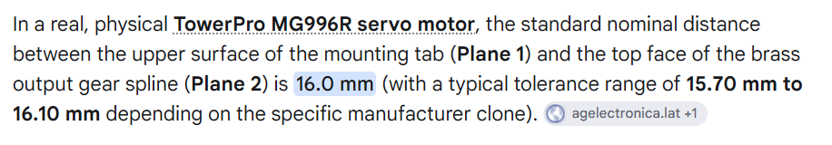

Complete Dimensions( from google)
- Length: 40.7 mm
- Width (Thickness): 19.7 mm
- Height: 42.9 mm
- Weight: 55 g

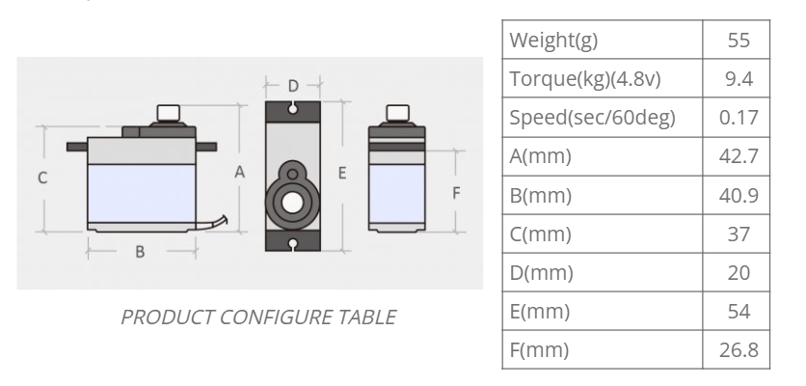

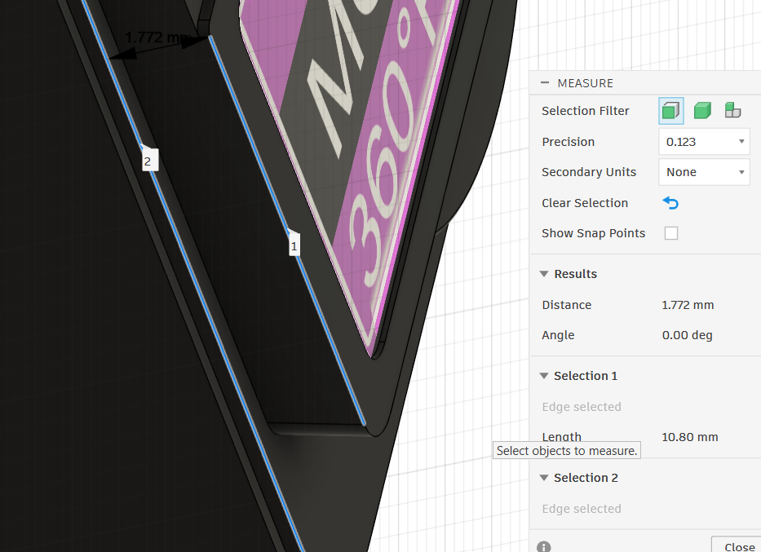
MG996R Servo

One important distance :1.772

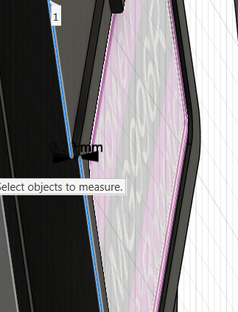
one more important distance :0.2mm

- Body length = 40mm
- Body width = 19mm
- Body height = 37.50mm

Mounting-hole spacings:
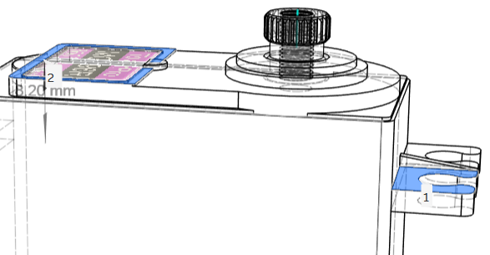
- Mounting-interface offset = 8.20mm

- mounting hole distance (1)=2mm
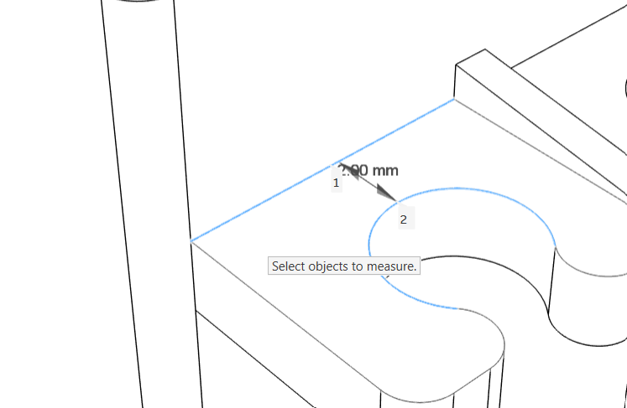

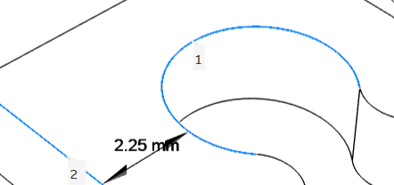
- mounting hole distance (2)=2.25mm

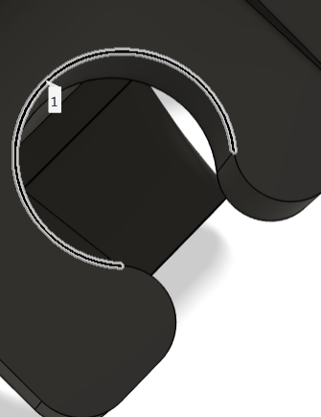

- . Servo mounting-hole diameter =4mm

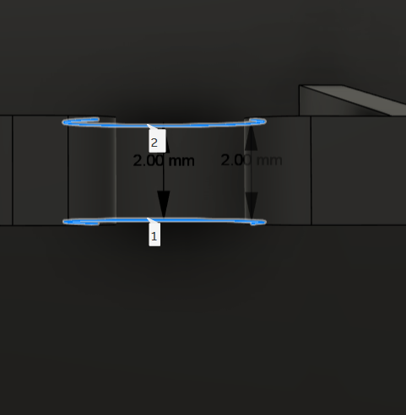
- Horn hub height =2mm

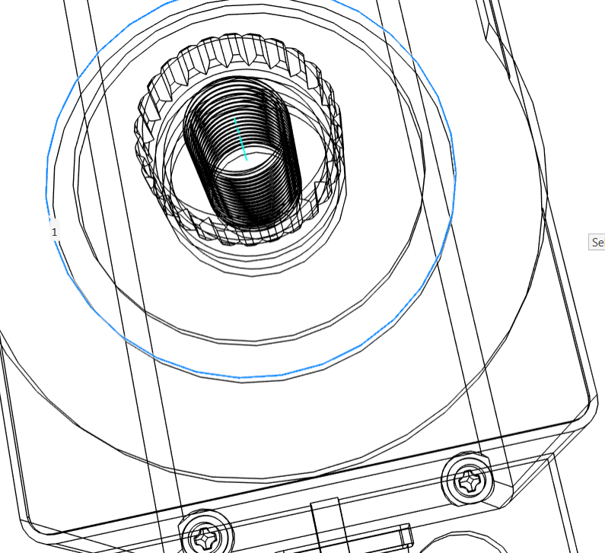
- servo output spline circle’s outer most diameter=13mm

- output spline length from the servo body=5.70mm

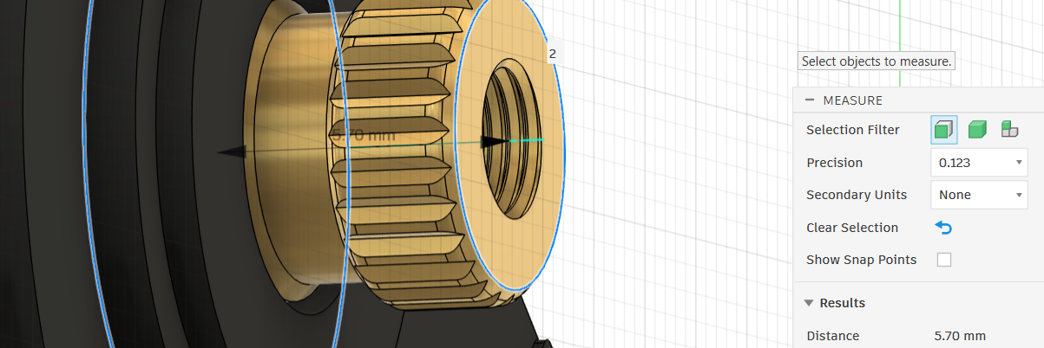

- put spline center diameter =//

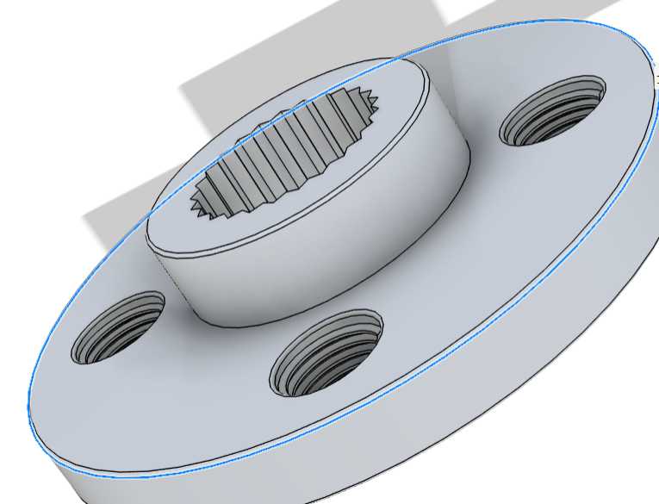
Servo Horn
- Outer diameter = 20.00 mm

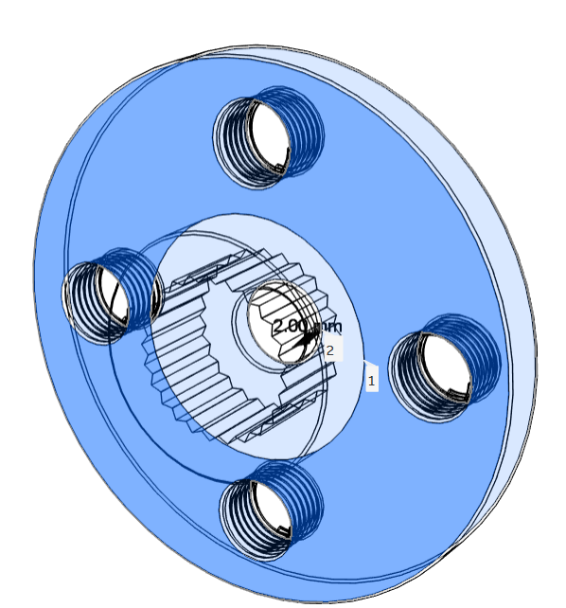

- Plate thickness = 2.00 mm

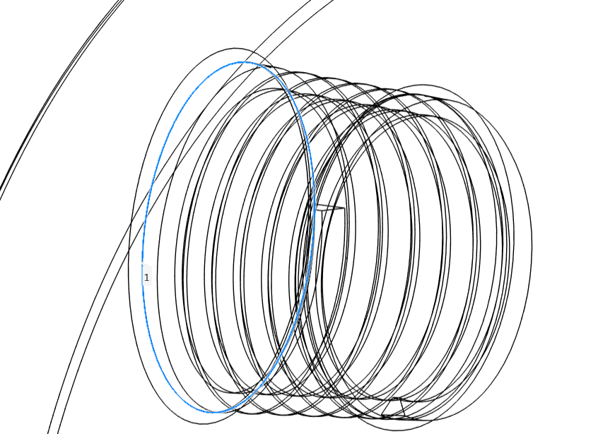
- horn borscrew diameter=3mm

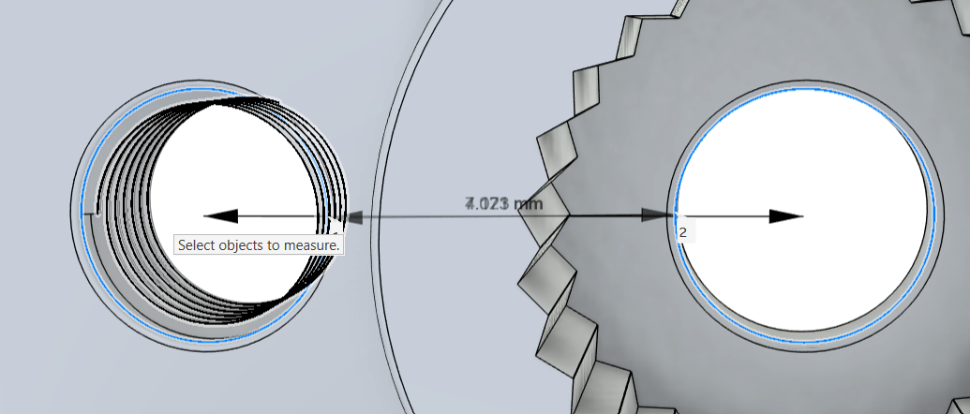
4) distance between two borscrew =7.071

Robot Arm
- DOF = 6
- Servos = 3 × MG996R +3 × MG90S
- Link 1 length = 130mm
- Link 2 length = 130mm
- Link thickness = ___
- Joint clearances = ___
- Fasteners = ___
- Bearing arrangement = ___

